_________________________________________________________________________

July 19th, 2011
CONCEPT NOTE

Government Electronic Payment Gateway (GePG)

Introduction
The Government of Moldova, as part of its e-transformation initiatives, is building a shared infrastructure – a new e-government technology platform using modern technologies such as cloud computing and offering multichannel access to information including access from mobile devices. At the Platform as a Service level, this environment has several shared services which are also known as enabling services since their successful implementation and operation will give a significant impetus to the development and usage of a broad set of electronic public services. One of these enabling services is Government e-Payment Gateway (GePG).

The GePG is an essential platform component within the e-government architecture. As a major building block of e-government, the GePG will enable transactional e-services as well as generally improve services delivered to citizens and enabling them to pay online for public services.

This paper describes the conceptual view of this service.

Terms and Definitions

Authentication | - | The process of identification of the user in an information system;
Authorization | - | The process of determining user’s rights in an information system;
ePG | - | Electronic Payment Gateway;
GePG | - | Government ePG;
ESB | - | Enterprise Service Bus;
G4B | - | Government for Business single window portal;
G4C | - | Government for Citizen single window portal;
M-Cloud | - | Moldova’s electronic services delivery platform based on cloud computing;
PSP | - | Payment Service Provider;
Platform service | - | A functionality that is consumed by sectorial or shared e-services such as payment and authentication;
Sectorial e-service | - | A public service that is specific to a sector, ministry or agency, and different from all other institutions. Tax. Education. Health e-services;
Shared government e-service | - | A function that is common to all government institutions such as accounting, financial management, communication, collaboration tools

Electronic Payments Today
Today in Moldova there only a dozen public services are available to the citizen electronically, out of over a hundred total services offered by the public sector. Most of the public services charge the citizens in accordance to regulated price lists. Although electronic services are proven to be much more convenient for citizens and efficient for authorities, still they suffer from a serious deficiency – the payment for the service is currently done physically at the counter of a bank. Thus, the current delivery of a typical payable electronic service is currently split into three phases:
- service initiation and data collection;
- payment for the service;
- payment confirmation and service provision.
The first phase is done online and consists of a set of preparatory activities, which gives the service provider comprehensive information about the user’s request. When the data is collected, the user is provided with payment information, i.e. the amount of money the user has to pay for the service plus all afferent costs, such as eventual transfer fees, shipping fees, emergency fees, etc. Some services offer the user the possibility to print the order so the user can take it to a bank. The payment step, outlined in phase 2 is currently done offline, i.e. the user physically goes to a bank counter to pay for the service. Usually service providers instruct their users that the payment shall be made in a specified number of working days, otherwise the service will not be provisioned. After paying for the service at the bank, the user has to wait for the order to be processed on the service provider’s side. Today, only a few electronic services have the ability to track the execution of the service. In the majority of cases, the user takes the receipt from the bank and goes to the service provider’s office to get finally served. It is clear that this service model is quite inconvenient for citizens, since they have to make at least two visits: one to the bank and another to the service provider. Many are of the opinion that such a lengthy and inconvenient process as outlined above in three phases is one of the main reasons why the number and uptake of electronic services is so low.

A quick solution for the service provider could be integration of its service with a payment service provider, considering the fact that recently several financial institutions announced that they could offer electronic payment services.
Although this may be convenient in a particular case, in general at the national level this solution is not efficient. There are several problems related to this approach:
- For each new service, the public service providers will have to implement integration with payment service;
- The complexity of integration increases when the service will need to support several payment methods, using different protocols, standards, technologies etc.;
- The costs of non-functional and security requirements will multiply with every new integration;
- Developers will have to understand and use APIs of a multitude of payment providers, thus making the costs for development considerably higher.
In other words, in order to support a mix of available payment methods, each service provider will have to integrate with every payment provider. The complexity of these relationships is n×m. The importance for a public service provider to offer integration to all payment options in a market is crucial, and only with this approach, the Government institutions are in a position that does not to discriminate or restrict citizen usage depending on what Bank or what payment method he or she subscribed to.
These problems could be efficiently solved by using a common platform level electronic payment gateway. The e-Government platform architecture contains such a gateway – the GePG, which is the platform level e-Payment service.

Platform architecture
As part of the e-Government technology platform, Moldova is building a new shared infrastructure which will allow ministries and agencies to host information systems within it. This infrastructure will be built using cloud computing – a mature and still promising technology which changes the delivery of IT services into an efficient model of self-service and pay per use provisioning of IT resources. For convenience purposes, this cloud computing technology will be called M-Cloud.

This platform is in essence a private cloud offering three main service delivery models – Infrastructure as a Service (IaaS), Platform as a Service (PaaS) and Software as a Service (SaaS).
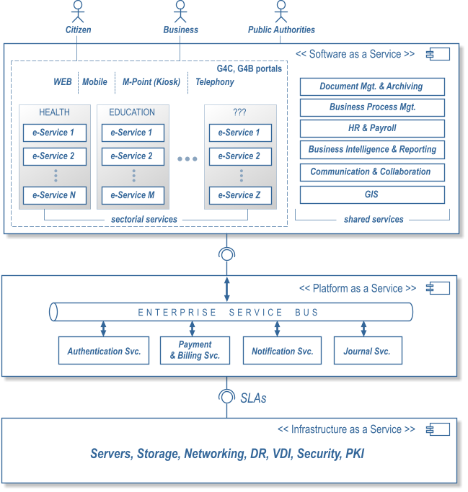
Fig. 1 The high level architecture of the e-government technology platform
The Infrastructure level services will mainly rely on re-using existing and upgraded service provision offered by the Center for Special Telecommunications. Using Government’s common infrastructure services will allow ministries and agencies to extend their IT capacity in a very short time frame. When requested resources are no longer necessary, the agency will be able to scale them down, therefore functioning on a pay-for-usage basis.

The Platform level services will offer common functionalities to business services operated by ministries and agencies on the Software as a Service level. At the time being, the architecture defines four re-usable Platform level services:
- Authentication and Access Control service (AAC) – provides a unified way to solve application security related tasks such as identity management, authentication, transaction authorization etc.;
- E-Payment service - provides a unified way to offer electronic payments;
- Notification service – provides a unified way to send notifications when needed, thus allowing for offline interaction with citizens;
- Journal service – provides a unified way to store and retrieve data regarding user activity and access within information systems.
Platform level services are intended to be utilized by current and future electronic services that ministries and agencies can develop.

The M-Cloud platform also contains a communication layer based on an enterprise service bus (ESB). Through this ESB, electronic services and information systems will be able to exchange messages. This in turn will allow creating complex business processes that are to be orchestrated by business process management tools.

Services delivered at the SaaS level could be grouped into two major categories – sectorial services and shared services.

Sectorial services are implemented and maintained by different sectors, such as education, healthcare, social protection etc. and directly consumed by citizens. Usually, sectorial services differ widely from ministry to ministry to public agency. However different the sectorial services, citizens will benefit from access through a common portal that is to be developed, called the Government for Citizen Portal. Access to the portal will be possible through different channels such as web, mobile or kiosks, in order to insure broad access of population to public electronic services.

Shared services at the SaaS level are those services which are used across ministries and agencies in similar ways. Examples of such services are electronic document management system, human resources and payroll system, CRM and reporting system. Usually, shared government services help optimize the work of public sector authorities and are done in a similar way from ministry to ministry and agency.

Platform level services design
Since platform level services will be re-used by many business services in a multitude of contexts, they will be highly configurable to accommodate different usage scenarios. On the other hand, it is a common practice and many private companies already have experience in providing commercial solutions for platform level services.
The architecture of platform level services will be based on provider architectural pattern, which decouples the generic service from its specific implementation. In this case vendors will have to conform to clear communication interfaces which act as technical contracts between components.

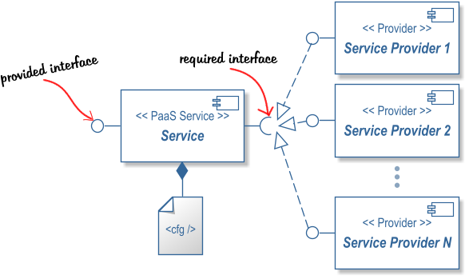
Fig. 2 The provider design pattern

This architecture of the platform level services offers important benefits. Among them are:
- Functional Flexibility – It is possible to configure different service providers to be invoked in different usage scenarios. It is also possible to use one or many providers for the same transaction if necessary (as in case of authentication for instance). In other words the solution is highly adaptive to different usage scenarios.
- Higher Availability – This design contributes to higher availability of the system, since if a service provider will fail still others are operable and the overall system continues to function.
- Cost Efficiency – The efficiency benefits are twofold. First, since the Service is a re-usable component it saves implementation and integration costs for each electronic service. Secondly, the design allows connection to multiple providers and leads to healthy competition between them, letting providers to compete on quality of service and on prices for the citizens.
- High Maintainability – The system’s components are highly decoupled and communicate through well-defined interfaces. All providers are connected through configurable parameters, which make it possible to add new providers or to disable existing providers on the fly.
- Neutrality – The design allows equal possibilities and conditions for providers to get on board and for citizens to decide who will serve him/her.
In the following sections these architecture principles will be translated to the GePG component and these benefits will be reflected in the further analysis.

e-Payment service
The Government e-Payment Gateway service will be offered to end users as part of the public service they are paying for, hence it is to be presented as a fine grain service in a service oriented setup, where each entity has governance over its own services and components, while the e-Government platform maintains the GePG as well as other platform services where all services are loosely coupled to create a more coarse grained service.
The primary aim of this service is to enable government agencies to offer electronic payment to the citizens. The gateway should enable connecting agencies to multiple Payment Service Providers (PSP), regardless of the payment methods they offer, and this is accomplished by having clear specifications for an interface at its both ends, namely with the Payment Service Providers and Government Service Providers as shown in the figure below.

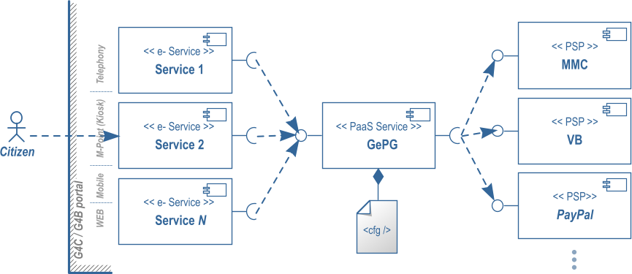
Fig. 3 Provider model applied to payment and billing
The main objective of this service is to consolidate payment handling functionalities (e.g.: encryption, integration with Payment Service Providers, logging, authentication of Payment Service Providers, etc.) and to release their provisioning to the private sector. In this way, the Government is sheltered from the legal liability due to fraud or misuse. This can be achieved by redirecting citizens to the Payment Service Provider of their choice on whose website the users enter the financial information and submit the electronic payment form. Sensitive e-Payment-related actions and information do not take place on the Government's side.
Therefore as presented in the GePG design, different Payment Service Providers will be integrated into the system, thus giving the citizen the freedom to choose between Payment Service Providers and proceed to specific payment authorization.

Typical online payment scenario
The typical online payment scenario is presented in the figure below.

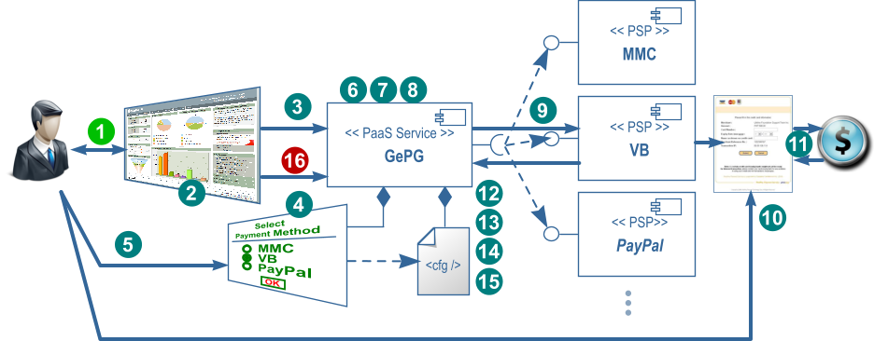

Fig. 4 Online payment scenario

The activities involved in this scenario are as follows:
- The user interacts with public service provided by Ministry/Agency through a single access window, the Government to Citizen Portal and accepts to pay by selecting “pay now” functionality of the service;
- Data entered by user to e-service gets validated by the public service provider
- e-Service redirects (sending along all the information that is required, like money amount, transaction identifier, etc…) the user to the e-Payment Gateway;
- The GePG shows a list of available payment methods which derives from the list of registered PSPs (As an extension it is possible to map e-services with specific PSPs if needed);
- User selects payment method and/or specific payment provider and clicks OK;
- The GePG appends some variables for tracking the payment transaction such as Callback Address, Timestamp, Trans-ID, etc.);
- The GePG creates and ciphers the redirection string;
- The GePG logs the transaction;
- The GePG redirects the user to the user’s preferred PSP website;
- The user lands on PSP secure payment authorization page and carries on the transaction successfully;
- Transaction gets successfully processed by the PSP’s backend systems;
- The PSP updates the user of the payment status and redirects him/her back to the GePG;
- The user’s browser passes the transaction status to the GePG;
- The GePG deciphers the string;
- The GePG logs the transaction indicating its source.
- The GePG sends the final result back encrypted to the Government Service Provider (including transaction’s contextual information) with its private key, while redirecting the user back to the e-service application from the Government Portal.

Risk control
Risk is controlled by allowing PSP to authorize a configurable sum of money and subsequently clearing it.
The clearance process takes two steps:
- The PSP notifies GePG when it instructs its bank to wire funds into Service Providers’ accounts and
- Service Providers notify GePG when they get confirmation about funds reaching their account from their Bank.
When the amount of authorized but not cleared funds reaches specific thresholds notifications will be distributed and subsequently barring will take place, meaning that the PSP could not be eligible for next payment transactions.

e-Service Providers
According to e-government strategy and architecture, primary service providers are Public Authorities. They will develop the sectorial e-services and will expose them through the national G4C/G4B portal. The services which will perceive some fees will use the GePG module.
Although the GePG is primarily designed for the public sector, it could be widely used by private companies in their e-commerce scenarios.
The envisioned procedure of enrollment for service providers is as follows:
- The service provider (government or private) should submit a letter introducing its business and expressing an interest in joining the national GePG;
- eGC will provide introduction materials to the service provider;
- Service provider has to sign some agreements to complete the membership to the gateway;
- eGC will switch service provider to production mode of the GePG after completion of mandatory test cases.

Payment Service Providers (PSP)
PSPs are economic agents, primarily financial institutions which activate according to local and international regulations. In order to integrate into the governmental electronic payment infrastructure they will have to sign a contract of payment service provision with Government.
The envisioned procedure of enrollment for PSP is as follows:
- The PSP should submit a letter introducing its business in a typical form and expressing an interest in joining the national e-Payment infrastructure;
- eGC will provide introduction materials to the PSP;
- Service provider has to sign some agreements (like NDA, membership agreement etc.) to complete the membership to the gateway;
- eGC will switch PSP to production mode of the GePG after completion of mandatory test cases.

Accessibility
The GePG shall be accessible through the same delivery channels as the originating e-service. In other words, if the user is accessing a payable e-service through a mobile device, then the GePG should offer its functionality (page listing payment options, confirmation pages etc.) through the same mobile channel.
The interface of the GePG shall be very intuitive and informative.
Along with regular interfaces (web, mobile), GePG will offer APIs for its core functionality, however full support for online payment scenarios mainly depends on PSPs.

Information Security
Although GePG itself does not perform proper funds transfer and only redirects user’s to a preferred PSP, its design must ensure maximum security for payment transaction. Interaction between user’s browser and GePG functionality is done using secured socket layer (SSL) technology to provide secure transmission of sensitive data and encryption.
Full liability on successful and secured payment transactions shall be on PSP side.

Analysis

Benefits
Benefits to citizen
- Pay for services and/or products securely and completely online.
- Use of e-Payment Gateway is free for citizens.
- Accepts all major available payment instruments.
- Save time and money.
Benefits to Government
- Payment for Services will be settled online.
- Organizations will save on Administrative cost.
- Reduced queuing at physical counters.
- Higher transparency on public revenues and expenses.
- Improved economy by direct transfer of funds.
- Full audit trail and reconciliation for online transactions available.
- Secure payment processing to world-class standards.
- Coordination of integration into e-payment infrastructure is done by a single entity that has extensive 'know how' of the business domain;
Benefits to Service Providers (or private merchants)
- Increased customer traffic due to easy payment option.
- Improved quality of electronic services due to possibility to fully automate services’ processes.
- Promotes cross-border e-commerce
- Complete support for retailers.
- Complete audit trail and reconciliation report provided.
- Secure payment processing to world-class standards.
- Online real time view of transactions.
- Reduced integration complexity due to implementation of a single payment protocol.
Benefits to Payment Service Providers:
- Increased number of transactions due to access to national payment infrastructure.
- Ability to compete freely and on equal conditions.

Sustainability
In order to ensure electronic payment service sustainability, the state may perceive some fees for using it. The following are the fees envisioned for different actors involved in main online payment scenarios.
Fees for citizen/individuals/buyers:
- None.
Possible fees for Service providers:
- One time joining fee – X MDL;
- Annual Maintenance fee – Y MDL;
- Transaction fee (Z % on transaction value per transaction). Rate will be defined by eGC.

Possible fees for PSP:
- One time joining fee – X MDL;
- Annual Maintenance fee – Y MDL
- Transaction fee (Z % on transaction value per transaction). Rate will be fixed by eGC.
The fees for public sector and private sector may differ and will be determined after a thorough economic analysis.

Future Extensions to ePG

Billing Service
As an extension to the direct online payment function we consider implementing a Billing Service that would allow consolidation of payments, i.e. the user may opt to send the payment request to the Billing Service instead of paying it immediately. At a later stage, the user accesses the Billing service and sees all the payments waiting to be processed. This service will be especially useful for postpaid services, acting like regular utility services.
This functionality will be developed as a subsequent phase of the project.

Shipping Service
An electronic payment integrated solution is incomplete if it does not allow material goods to be delivered to the end user. Material goods require shipment and delivery infrastructure which could be considered as another enabler for mass uptake of electronic services.
Although Shipping Service is logically tied to e-Payment service (in most cases you pay for the goods and after that they get delivered to you), still this service will be implemented completely decoupled from GePG. The model will be similar allowing a central gateway to concentrate Shipment Providers into a single gateway for Service Providers to rely upon. This solution shall be able to operate with the multitude of shipment constraints and expectations such as urgency, container sizes, weights of shipped goods, package tracking etc.
This functionality will be developed as a subsequent phase of the project.

Legal requirements for electronic payments
Electronic payment legislation is not yet outlined, nevertheless there is a draft law on electronic money – “Legea cu privire la serviciile de plata si moneda electronica”, issued by National Bank of Moldova for public consultations. Once adopted, the national e-Payment infrastructure shall conform to this law.

Implementation considerations
It would have been best if a Private Sector Electronic Payment Gateway was available for peruse by both Public and Private sector services. Still, at the moment no such Electronic Payment Gateway has got any widespread adoption in Moldova. Under these conditions the e-Government Centre intends to develop such a solution from scratch. Even so, it will start in a staged manner with small investments of funds, time and effort and observe how the market and the payment services evolve. If competitive alternatives appear on the market the e-Government Centre will assess their role and reconsider further reliance on electronic payments being developed by the Government. If no alternatives appear or mature in due time subsequent stages of the service development will be considered in order to extend and enhance the capabilities offered.

Testing platform
The Government shall offer a testing payment platform for both e-services developers and PSPs. Service providers and PSPs shall test their products using this platform prior integrating them into the production.

Risks
The following major risks are identified:
- Payment via electronic means such as Credit/Debit cards did not "take off" in Moldova. The Payments and Billing service tries to ease the process and to introduce an increased level of trust into electronic funds transfers by individuals but this cannot be guaranteed.
- Currently there are legislative initiatives to regulate the field of electronic payments, electronic payment services and electronic money. These initiatives can be seen as a barrier to entry for newcomers and innovators in the field and protect the incumbent players who failed to innovate. This has the potential to compromise the usefulness of the Payment and Billing service since it depends entirely on the existence and affordability of Electronic Payment Providers to support the service.
- Service Providers operate sometimes with multiple bank/treasury accounts that receive the actual money when a payment is made. This causes the need that the account details, including Bank, Bank Identifiers, Routing Numbers, Account Numbers, Service Provider Identities and possibly other attributes to be included in the payment requests/responses so the Payment Provider is able to correctly wire the funds. This introduces additional complexity to the final solution.

Next steps
In order to proceed with further implementation, the following set of issues should be clarified during public consultations.

# | Criterion | Description
1. | Cost of implementation | How much it will cost the state to implement the GePG?
2. | Cost of maintenance | How much the state will have to pay yearly to keep the e-payment infrastructure functioning?
3. | Implementation timeframe | How long it will take to implement the system? When it could be potentially launched?
7. | Technical support | How the users will be supported in using the Payment Gateway? Who will offer that support?
8. | Private/banking sector uptake | To what extent the private sector will use this system for their solutions?
9. | Security | What additional security measures should be taken to ensure a reliable and secure functionality of the system?

Planned next steps are:

- To consult and validate with National Bank of Moldova the approach on e-payment.
- To consult private sector, including commercial banks (mid July 2011), on:
  - Would they be interested to participate in the scheme as Payment Providers?
  - What sustainability model for the GePG would they recommend?
- To consult private companies (mid July 2011), on:
  - Would they be interested to participate in the scheme as merchants in e-commerce scenarios using GePG?
  - What sustainability model for the GePG would they recommend?
- To consult public institutions which currently offer electronic services with offline payment on the proposed model.
- To identify what are the required changes/updates in the regulatory framework and how the changes should be adopted (mid July 2011).

References
- Proiect Legea cu privire la serviciile de plată şi moneda electronică

